

Year 7 Science 2023 Name: __**ANSWERS**___________

**Earth and Space 2 Test**

**SECTION 1: MULTIPLE CHOICE** (1 mark each)

1. Rocks are weathered to form materials that can then form part of a soil. Soils would therefore contain the following material that was originally part of the rock:
   1. Air
   2. Water
   3. **Minerals**
   4. Humus
2. The agents of erosion are:
   1. Water, air, wind and sunlight
   2. Ice, water, gases and rain
   3. Water, wind and rain
   4. **Wind, water and ice**
3. Soils are not renewable because they:
   1. can be eroded.
   2. **are replaced too slowly**.
   3. are formed from weathering of rocks.
   4. can be weathered.
4. Select the alternative that cannot be used to produce biomass.
   1. Decomposing fruit peelings and grass clippings
   2. Human sewage and animal wastes
   3. Fermented sugarcane
   4. **Recycled aluminium**
5. Which of the following is true about the Sun?
   1. Plants use sunlight to produce food.
   2. It warms the Earth’s atmosphere.
   3. It is a renewable resource.
   4. **All of the above**.

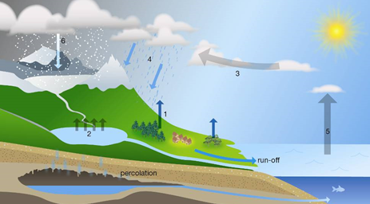*For Question 6 and 7 use the diagram to answer the questions*

1. State the process occurring at position 2.
   1. Precipitation
   2. **Evaporation**
   3. Condensation
   4. Transpiration
2. State the process that has occurred at position 1.
   1. Precipitation
   2. Evaporation
   3. Condensation
   4. **Transpiration**
3. State the largest source of evaporation in the water cycle.
   1. **The oceans, because they are the largest bodies of water**
   2. Vegetation, because the leaves of trees and other plants have such a large surface area
   3. Turbulent rivers and streams and waterfalls where there is a lot of spray going into the air
   4. Spray irrigation of large agricultural areas
4. Human activities have upset the natural water cycle in many places. Select the human activity that is an attempt to restore an aspect of the natural water cycle.
   1. Irrigation of crops
   2. Replacing forest with food crops
   3. Building of dams
   4. **Construction of rain gardens**

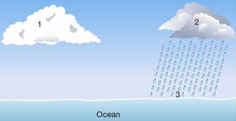

1. Using the information provided in the diagram, identify which of the following statements is ***true*.**
   1. The air at 1 is saturated.
   2. Evaporation is taking place at 3.
   3. Run-off will occur when the precipitation reaches 3
   4. **The water droplets at 1 are smaller than at 2.**

**SECTION 2: WRITTEN**

**Write your answers in the spaces provided.**

1. **Explain** the difference between renewable and non-renewable resources. Give an example of each type of resource. (3 marks)

Renewable resources are able to be replaced within about a human lifetime 1 mark

Any renewable resource eg sunlight, water, air, living things 1 mark

Any non renewable resource eg Fossil fuels, Rocks, Soil. 1 mark ____________________________________________________________________________________________________________________________________________________

1. **Name and describe** how two renewable energy sources can used . (4 marks)
2. Name 1 mark any description of how used 1 mark _______________________________________________________________________________________________________________________________________________________________________________________________________________
3. Name 1 mark any description of how used 1 mark __________________________________________________________________________________________________________________________________________________________________________________________________________________
4. **Match** the water cycle terms to their correct definition. (6 marks)

Condensation, Precipitation, Run – off, Evaporation, Transpiration, Percolation

|  |  |
| --- | --- |
| **Water Cycle Term** | **Definition** |
| Percolation | The process of water soaking into the soil |
| Condensation | Change of state from water vapour to liquid water |
| Precipitation | Any water falling out of the sky |
| Evaporation | Change of state from liquid water to water vapour |
| Run off | Water not absorbed by the soil |
| Transpiration | Evaporation of water from plants |
|  |  |

1. What is the difference between pervious and impervious rock? (1 mark)

Water can go through pervious rock but not impervious rock. 1 mark __________________________________________________________________________________________________________________________________________________

1. Diagram below shows a soil profile

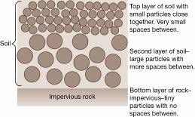

a) Describe what could happen to water falling on the surface of the soil. (2 marks)

Soak into soil/Percolate 1 mark

Run off 1 mark ______________________________________________________________________________________________________________________________________________________

b) Compare what would happen to the water if there was extremely heavy rainfall rather than a steady shower of rain. (2 marks)

Fill soil air spaces/Waterlog soil

Run off Any two, 1 mark each

Cause erosion _________________________________________________________________________

1. A student conducted an experiment to test the rate of percolation through different soil types.

She cut a hole in the bottom of a plastic cup and put a small piece of flyscreen over the hole. Then she put the cup in a retort stand and placed a beaker underneath the hole. A diagram of how she set up her equipment is shown on the right.

To test each soil, she filled the cup to the top and poured 100mL of water through the soil. She timed how long it took for the water to move through the soil to the beaker.

1. In this experiment, name (4 marks)

* the independent variable (changed) _Type of soil_____1 mark_____
* the dependent variable (measured) Rate of percolation(or similar) 1 mark
* **two** controlled variables (kept the same) _volume of soil, volume of water,other

size of hole, flyscreen

Any two 1 mark each

The student’s results are shown in the table below. Draw a column graph of her results.

(5 marks)

|  |  |
| --- | --- |
| **Soil Type** | **Time (minutes)** |
| Sand | 4 |
| Gravel | 1.5 |
| Clay | 10 |
| Loam | 7.5 |

|  |  |  |  |  |  |  |  |  |  |  |  |
| --- | --- | --- | --- | --- | --- | --- | --- | --- | --- | --- | --- |
|  |  |  |  |  |  |  |  |  |  |  |  |
|  |  |  |  |  |  |  |  |  |  |  |  |
|  |  |  |  |  |  |  |  |  |  |  |  |
|  |  |  |  |  |  |  |  |  |  |  |  |
|  |  |  |  |  |  |  |  |  |  |  |  |

Title – must contain both variables

Graph – column graph

1 mark each Both axes labelled

Axes right way around/size of graph

Unit (minute) labelled and scale correct

1. Which soil did the water percolate through the fastest? (1 mark)

____Gravel_____________

1. Which soil did the water percolate through the slowest? (1 mark)

______Clay_____________

**END OF TEST (OUT OF 39 MARKS)**